
Дисциплина: Технология и инструментальные средства разработки ПО
Отчет по практической работе №2.3: «API каталога с фильтрацией, поиском, сортировкой».

Выполнил:
Группа: 3-ИСП9-54
Студент: Мкртчян Юрик

Проверил преподаватель:
Кондыбаева А.Б.

Москва 2026 г.

1. Листинги скрипта
import datetime
import json
import mimetypes
import os
import sqlite3
from http.server import BaseHTTPRequestHandler, HTTPServer
from urllib.parse import parse_qs, urlparse

BASE_DIR = os.path.dirname(os.path.abspath(__file__))
STATIC_DIR = os.path.realpath(os.path.join(BASE_DIR, "static"))
DB_PATH = os.path.join(BASE_DIR, "shop.db")
DISCOUNT = 0.25
LOW_STOCK = 3

mimetypes.add_type("text/html", ".html")
mimetypes.add_type("text/css", ".css")
mimetypes.add_type("application/javascript", ".js")

def db():
conn = sqlite3.connect(DB_PATH)
conn.row_factory = sqlite3.Row
conn.execute("PRAGMA foreign_keys = ON")
return conn

def api_login(query):
login = query.get("login", [""])[0].strip()
if not login:
return 400, {"error": "Не указан логин"}
conn = db()
row = conn.execute(
"SELECT u.id, u.full_name, r.name AS role FROM Users u "
"JOIN Roles r ON r.id = u.role_id WHERE u.login = ?", (login,)).fetchone()
conn.close()
if not row:
return 404, {"error": "Пользователь с логином «{}» не найден".format(login)}
return 200, dict(row)

def ordered_last_month(conn):
first_cur = datetime.date.today().replace(day=1)
first_prev = (first_cur - datetime.timedelta(days=1)).replace(day=1)
rows = conn.execute(
"SELECT DISTINCT oi.product_id FROM OrderItems oi JOIN Orders o ON o.id = oi.order_id "
"WHERE o.order_date >= ? AND o.order_date < ?", (first_prev.isoformat(), first_cur.isoformat()))
return {r[0] for r in rows}

def add_price(product, ordered):
if product["id"] in ordered:
product["discount"] = 0
product["price_final"] = product["price"]
else:
product["discount"] = int(DISCOUNT * 100)
product["price_final"] = round(product["price"] * (1 - DISCOUNT), 2)

def api_products(query):
category = query.get("category", [""])[0].strip()
search = query.get("search", [""])[0].strip().lower()
sort = query.get("sort", [""])[0].strip()
if sort not in ("", "price_asc", "price_desc"):
return 400, {"error": "Недопустимое значение sort: " + sort}
sql = ("SELECT p.id, p.name, c.name AS category, m.name AS manufacturer, p.description, "
"p.price, p.image, "
"COALESCE((SELECT SUM(s.quantity) FROM Stock s WHERE s.product_id = p.id), 0) AS stock "
"FROM Products p "
"JOIN Categories c ON c.id = p.category_id "
"JOIN Manufacturers m ON m.id = p.manufacturer_id")
params = []
if category:
sql += " WHERE c.name = ?"
params.append(category)
conn = db()
products = [dict(r) for r in conn.execute(sql + " ORDER BY p.id", params)]
ordered = ordered_last_month(conn)
conn.close()
if search:
products = [p for p in products if search in p["name"].lower()]
for p in products:
add_price(p, ordered)
p["stock_level"] = "мало" if p["stock"] <= LOW_STOCK else "много"
if sort:
products.sort(key=lambda p: p["price_final"], reverse=(sort == "price_desc"))
return 200, products

class Handler(BaseHTTPRequestHandler):
def send_json(self, status, data):
body = json.dumps(data, ensure_ascii=False).encode("utf-8")
self.send_response(status)
self.send_header("Content-Type", "application/json; charset=utf-8")
self.send_header("Content-Length", str(len(body)))
self.end_headers()
self.wfile.write(body)

def do_GET(self):
url = urlparse(self.path)
query = parse_qs(url.query)
if url.path == "/api/login":
self.send_json(*api_login(query))
elif url.path == "/api/products":
self.send_json(*api_products(query))
else:
self.send_static(url.path)

def send_static(self, path):
if path == "/":
path = "/index.html"
file_path = os.path.realpath(os.path.join(STATIC_DIR, path.lstrip("/")))
if not file_path.startswith(STATIC_DIR + os.sep) or not os.path.isfile(file_path):
self.send_json(404, {"error": "Файл не найден: " + path})
return
content_type = mimetypes.guess_type(file_path)[0] or "application/octet-stream"
if content_type.startswith("text/") or content_type == "application/javascript":
content_type += "; charset=utf-8"
with open(file_path, "rb") as f:
data = f.read()
self.send_response(200)
self.send_header("Content-Type", content_type)
self.send_header("Content-Length", str(len(data)))
self.end_headers()
self.wfile.write(data)

def do_POST(self):
path = urlparse(self.path).path
if path != "/api/echo":
self.send_json(404, {"error": "Неизвестный метод API: " + path})
return
length = int(self.headers.get("Content-Length", 0))
try:
data = json.loads(self.rfile.read(length).decode("utf-8"))
except ValueError:
self.send_json(400, {"error": "Некорректный JSON"})
return
self.send_json(200, {"received": data})

if __name__ == "__main__":
HTTPServer.allow_reuse_address = False
server = HTTPServer(("127.0.0.1", 8000), Handler)
print("Сервер запущен: http://localhost:8000")
try:
server.serve_forever()
except KeyboardInterrupt:
print("Сервер остановлен")
server.server_close()

2. Скриншоты
Рисунок 1 – ответ api/products
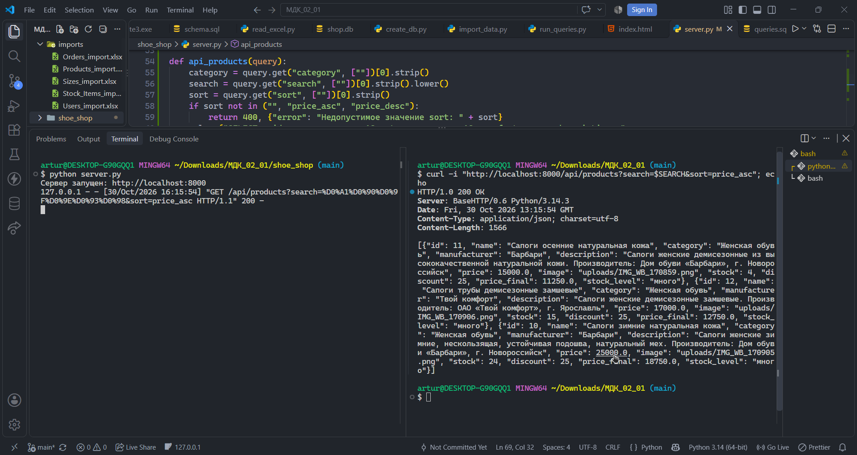
Рисунок 2 – Фильтр по категории женская обувь с сортировкой по убыванию цены.

